Jason Henson

[jah926@arastudent.ac.nz](mailto:jah926@arastudent.ac.nz)

11400870

Question 1:

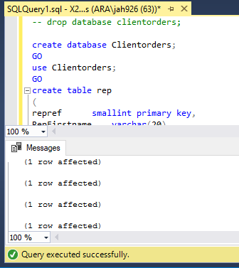

Question 2:

SELECT firstname, lastname, city FROM client

WHERE city = 'Dunedin'

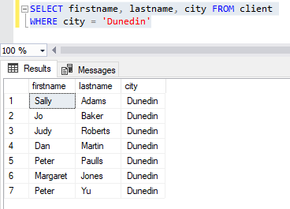

Question 3:

SELECT firstname, lastname FROM client

WHERE lastname LIKE 'J%'

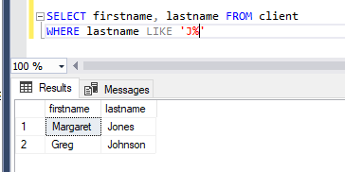

Question 4:

SELECT firstname, lastname, balance FROM client

WHERE balance BETWEEN '50' AND '150'

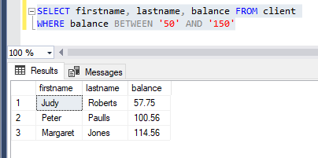

Question 5:

SELECT firstname, lastname, city FROM client

WHERE firstname = 'Mary'

AND lastname = 'Nelson'

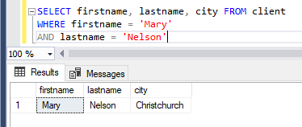

Question 6:

SELECT firstname, lastname, balance, city FROM client

WHERE city = 'Dunedin'

AND balance < '200'

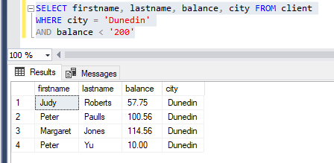

Question 7:

SELECT custref, creditlimit, balance, (creditlimit - balance) AS 'NewBalance'

FROM client

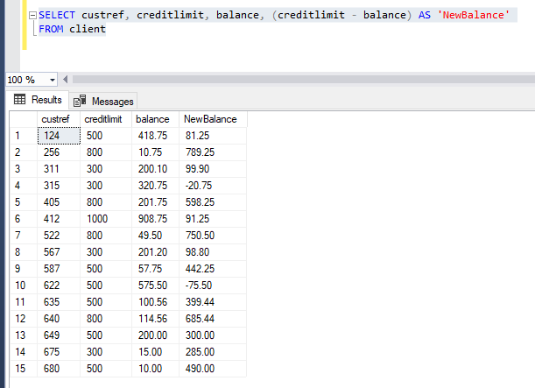

Question 8:

SELECT orderref, partref, quantity, quotedprice,

(quantity * quotedPrice) AS 'LineTotal'

FROM orderline

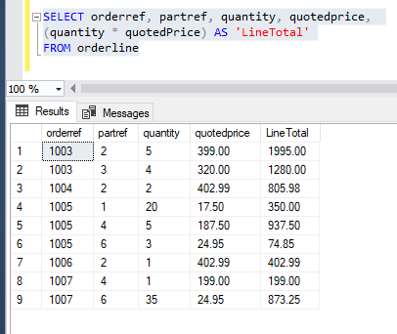

Question 9:

SELECT orderref, orderdate

FROM custorder

-- Convert NZ format to American format

WHERE orderdate > '6-1-99'

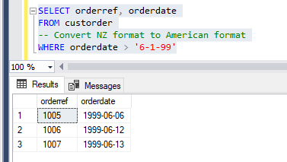

Question 10:

SELECT city, COUNT(custref) AS 'Number in each city'

FROM client

GROUP BY city

HAVING COUNT(custref) > 3

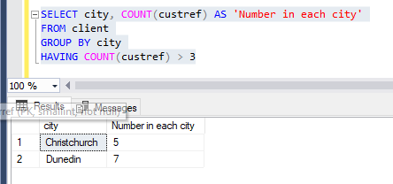

Question 11:

SELECT repref, SUM(client.balance) AS 'Total balance'

FROM client

GROUP BY repref

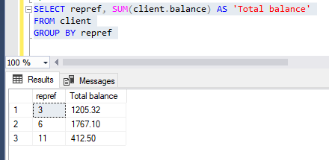

Question 12:

SELECT TOP 3 city, SUM(balance) AS 'Maximum Balance'

FROM client

GROUP BY city

Question 13:

SELECT CONCAT_WS(' ', c.firstname, c.lastname) AS 'Client name',

CONCAT_WS(' ', r.RepFirstname, r.RepLastName) AS 'Rep name'

FROM client c

INNER JOIN rep r

ON c.repref = r.repref

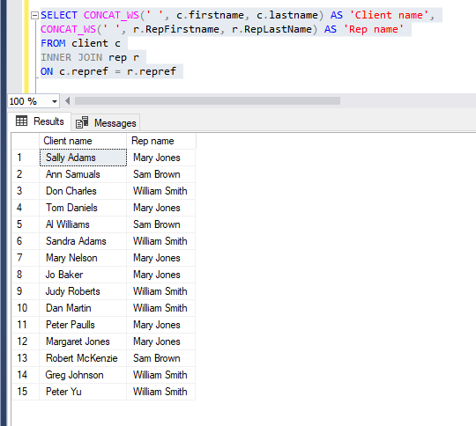

Question 14:

SELECT co.orderref, c.firstname, c.lastname, co.orderdate

FROM client c

INNER JOIN custorder co

ON c.custref = co.custref

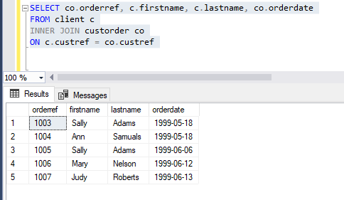

Question 15:

SELECT ol.orderref, p.description, p.onHand

FROM orderline ol

INNER JOIN part p

ON ol.partref = p.partref

GROUP BY ol.orderref, p.description, p.onHand

HAVING ol.orderref = '1007'

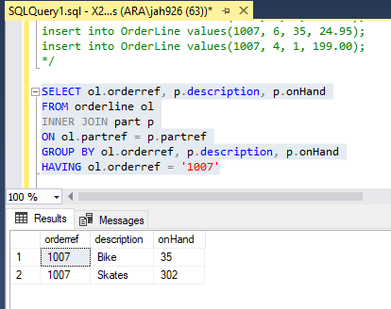

Question 16:

SELECT ol.orderref, p.description, ol.quotedPrice, ol.quantity

FROM orderline ol

INNER JOIN part p

ON ol.partref = p.partref

ORDER BY p.description

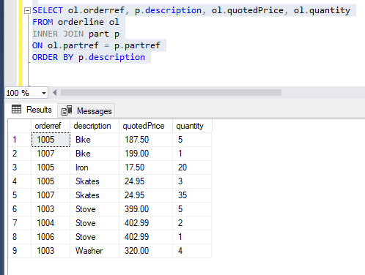

Question 17:

SELECT ol.orderref, p.description, ol.quotedPrice, ol.quantity

FROM orderline ol

INNER JOIN part p

ON ol.partref = p.partref

WHERE ol.quotedPrice > 200

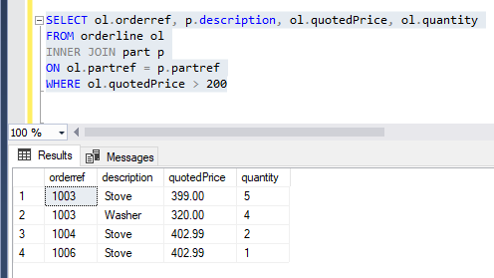

Question 18:

SELECT co.orderref, co.orderdate,

c.firstname, c.lastname,

p.description, p.unitPrice

FROM custorder co

INNER JOIN client c

ON c.custref = co.custref

INNER JOIN orderline ol

ON ol.orderref = co.orderref

INNER JOIN part p

ON ol.partref = p.partref

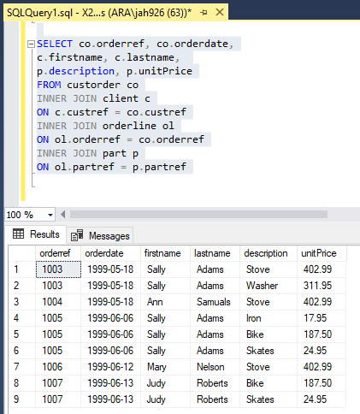

Question 19:

SELECT co.orderref, co.orderdate,

c.firstname, c.lastname,

p.description, p.unitPrice

FROM custorder co

INNER JOIN client c

ON c.custref = co.custref

INNER JOIN orderline ol

ON ol.orderref = co.orderref

INNER JOIN part p

ON ol.partref = p.partref

-- Convert NZ Date to US Date

WHERE co.orderdate > '06/10/99'

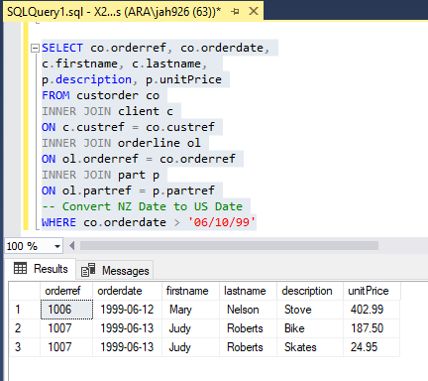

Question 20:

SELECT co.orderref, co.orderdate,

c.firstname, c.lastname,

r.RepFirstname, r.RepLastName,

p.description

FROM custorder co

INNER JOIN client c

ON c.custref = co.custref

INNER JOIN rep r

ON r.repref = c.repref

INNER JOIN orderline ol

ON ol.orderref = co.orderref

INNER JOIN part p

ON ol.partref = p.partref

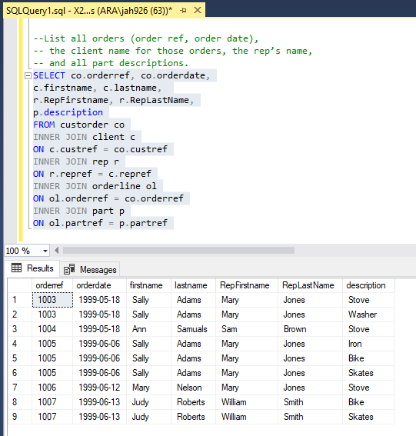

Question 21:

SELECT CONCAT_WS(' ', r.RepFirstname, r.RepLastName) AS 'Rep Name',

SUM(c.balance) AS 'Total Balance'

FROM client c

INNER JOIN rep r

ON r.repref = c.repref

GROUP BY r.RepFirstname, r.RepLastName

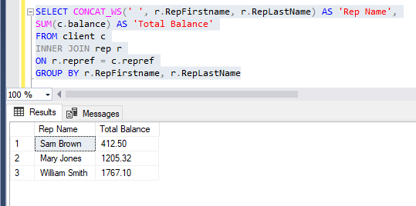

Question 22:

SELECT orderref, SUM(quantity * quotedprice) AS 'Total Linetotal'

FROM orderline

GROUP BY orderref

